

# BrailleNote Touch 18 Plus

## Type of device: Tablet

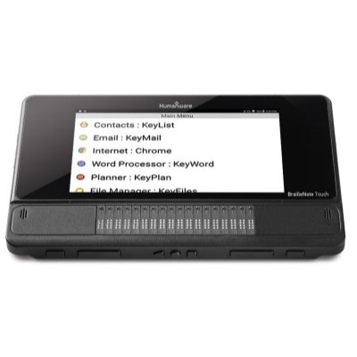

Actual Display Size : 10.5"

Operating System : Google Android

Version Number : 8.1

Year of Release : 2019

Average Price : $5345 as of 03 06 2020

Internet Access : Wi-Fi Only

## Accessibility Features:

### Cognitive

* Additional Instructions
* Copy and Paste
* Flicker Free Display
* GPS
* Screen Timeout Disabled
* Simple Instructions
* Simple Reminders
* Simplify Display

Voice Notes

### Hearing Impairment and Deaf

* Bluetooth or Wi-Fi
* Vibrating Alerts - Adjustable

Visual Alerts - Incoming Calls

### Vision

* Battery Alert - Audible
* Bluetooth or Wi-Fi
* Braille Display Support
* Key Press - Vibration or Click
* Personalised Shortcuts
* Screen Reader

Voiced Menus

### Speech

Messaging Options - Email

### Physical

* Bluetooth or Wi-Fi
* Flat Back for Table Top Operation
* Headset - plug connected
* Reduced hand movement option
* Speaker-phone option

Visible Focus Indicators

## How and where to get it from?

You can buy this tablet from [Vision Australia](https://shop.visionaustralia.org/shop/product/braillenote-touch-18-plus), [Humanware](https://store.humanware.com/hca/blindness-braillenote-touch-plus-18.html), and other retailers.

## More information is available on:

[BrailleNote Touch 18 Plus Webpage](https://store.humanware.com/hca/blindness-braillenote-touch-plus-18.html)

[BrailleNote Touch 18 Plus User Guide (PDF Download)](http://support.humanware.com/Site/Files/a/06cc20404d351cbaa2520fcd0d5adc3/f117ef24d066dbd8a70fcaf08af3d539/EN-UG%20BNTouchPlus.pdf)

[BrailleNote Touch 18 Plus Audio Tutorials](http://support.humanware.com/en-canada/support/braillenote_touch_plus/audio_tutorials)

[BrailleNote Touch 18 Plus Command Summary (PDF Download)](http://support.humanware.com/Site/Files/a/06cc20404d351cbaa2520fcd0d5adc3/cb977e3ef54b59e6e8381095ef43fa32/ACCD-0215-EN-CS-BNTouchPlus-REV-03.pdf)